**City University of Hong Kong**

**School of Continuing and Professional Education**

**PROGRAMME - {173-19431}**

**BSc (Hons) Information Technology for Business (3-yr Full Degree)**

**Coventry University**

**205CDE**

**Reflective Report**

**Name: LI Yat Long**

**Student ID: 55201950**

**Git-hub:** **https://github.com/vincennt99v1123li/205CDE.git**

**Youtube: https://youtu.be/OKZEFszPj9c**

Table of Contents

Introduction 3

Features of the system 4

Main webpage 4

Staff webpage 9

Design 13

Structure of web site 13

Code 16

Python 16

Html, Bootstrap, CSS 20

JavaScript, jQuery 26

Database design 29

Recommendation for browsers 31

Browser version 31

OS version 31

Evaluation 31

Future development 31

List of References 32

# Introduction

The ‘VincentStore’ is an online supermarket which provides a variety of products for our daily life like foods or drinks. Customer can purchase anytime anywhere through internet and the products will be delivered to their desired location like home.

Our stores provide an easy to use interface with lower price and delivery date than other common online supermarket companies, which is believed is the strength of our newly opened store.

To purchase in our store, customer need to register an account and login to the website. Then our customer could select the product with its quantity and add to the shopping cart. Customer could decide whether they are confirmed to purchase the product in the shopping cart session of the website. If customer would like to purchase the selected items in the shopping cart, they just need to pay with their credit card and a receipt will be both shown on screen or through email. Customer could later check their orders in My account session which list all of the purchase record.

Not only the system benefits the customer, it also provides a easy to use web page for a staff during daily operation. This system provides a similar interface to the customer website and allow the staff to update the details of the products like price. Moreover, the system also provides an easier way for our staff to view the orders from our customer and an interface to update the delivery date in case they need.

# Features of the system

## Main webpage

* Account
  + Register new account (necessary for purchase)
  + 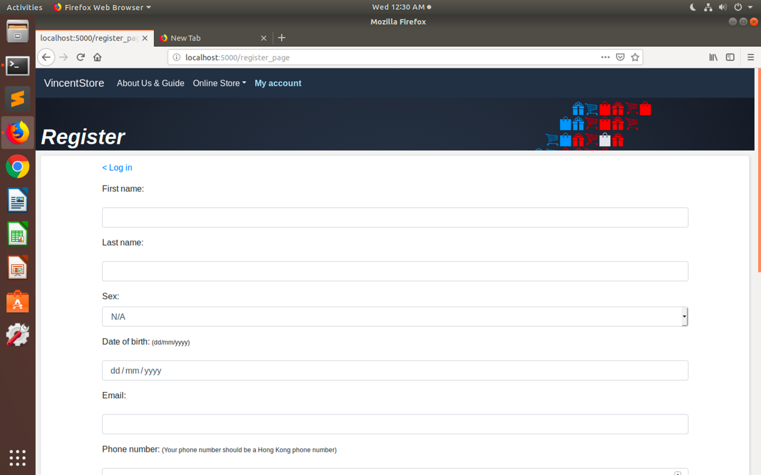
    - Email
    - 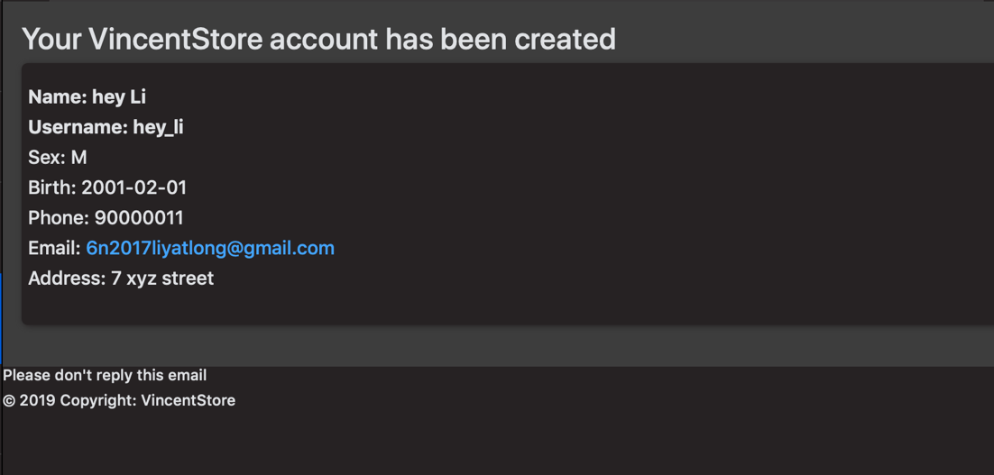
    - A mail account will be sent after register to remind user
  + Login/ logout
  + Modify current account details
  + 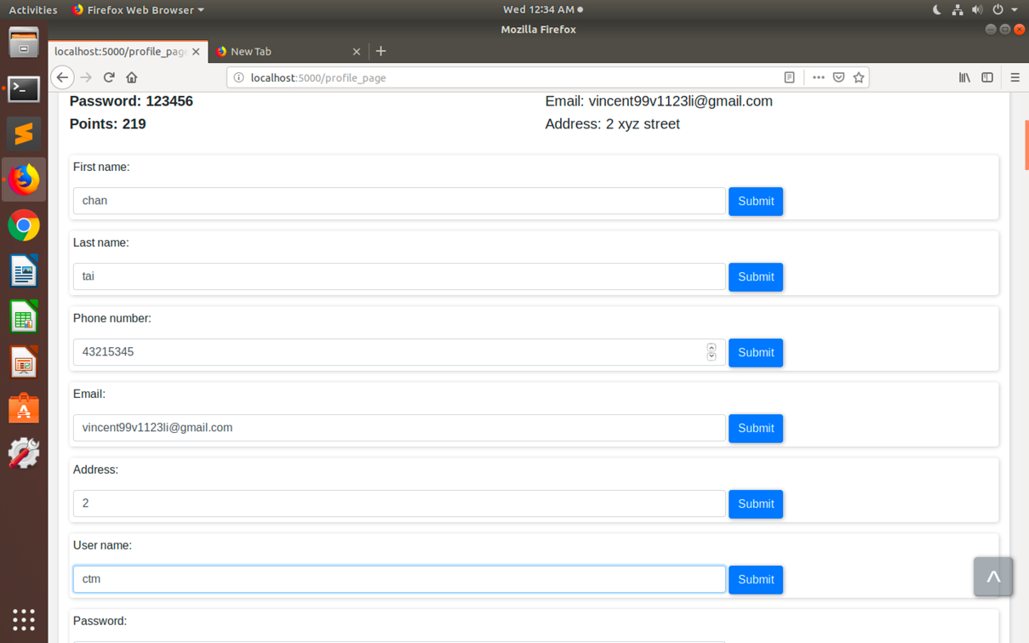
    - E.g. Name, email, username, password
    - Email alert which alert user to see if they change the item by themselves, not hackers
    - 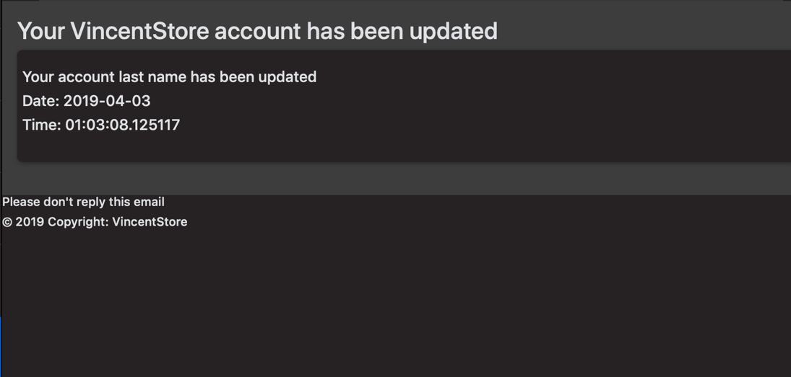
* View product
  + Sort by product category/ product price/ brand or name
  + 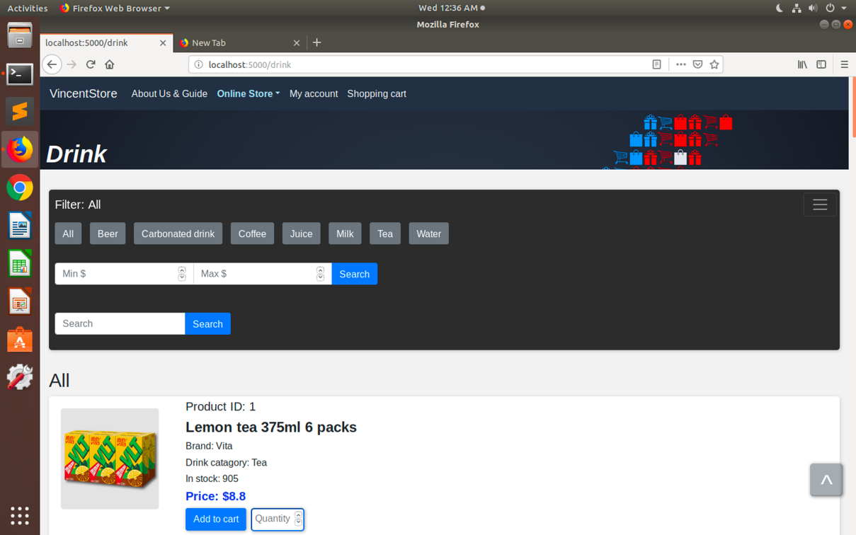
  + Easier to find the products which meets requirements
* Shopping cart
  + Add product in batch (maximum 10 each time)
  + List all the products in shopping cart
  + 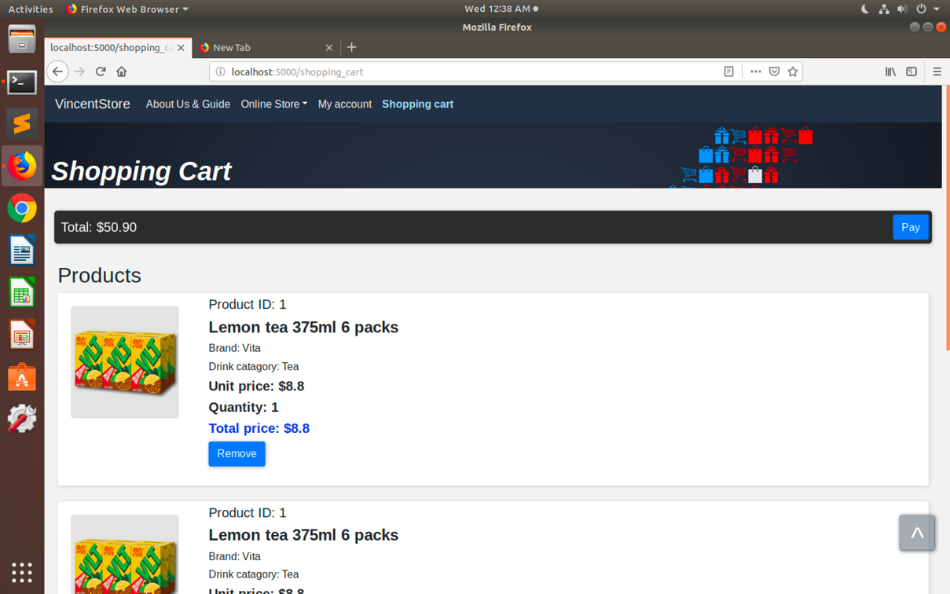
  + Option to remove products from shopping cart in case customer desired to do that
  + Display total price, total price of each product and unit price of each product
* Receipt
  + List all the detail of that purchase, which allow user to confirm if its correct or not
  + 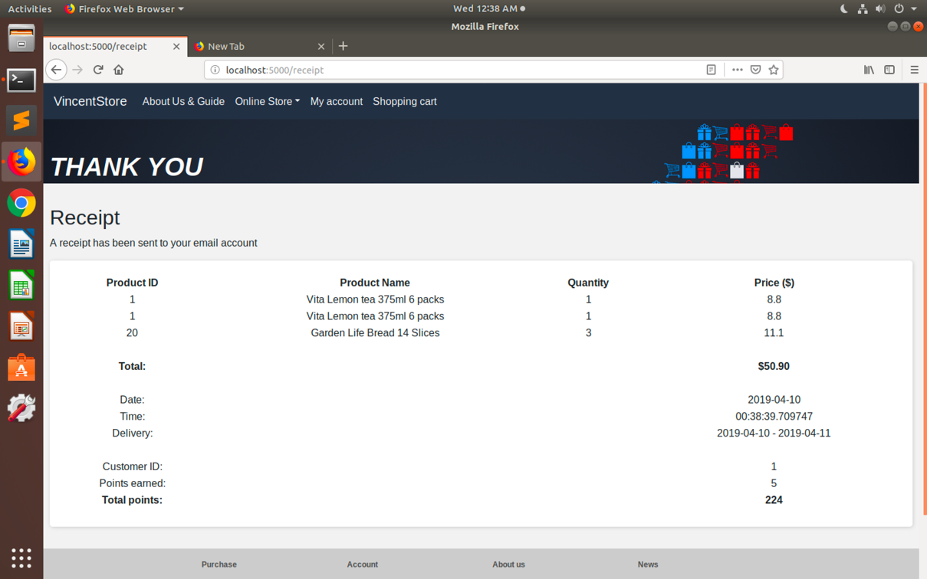
  + Email version (backup for user)
  + 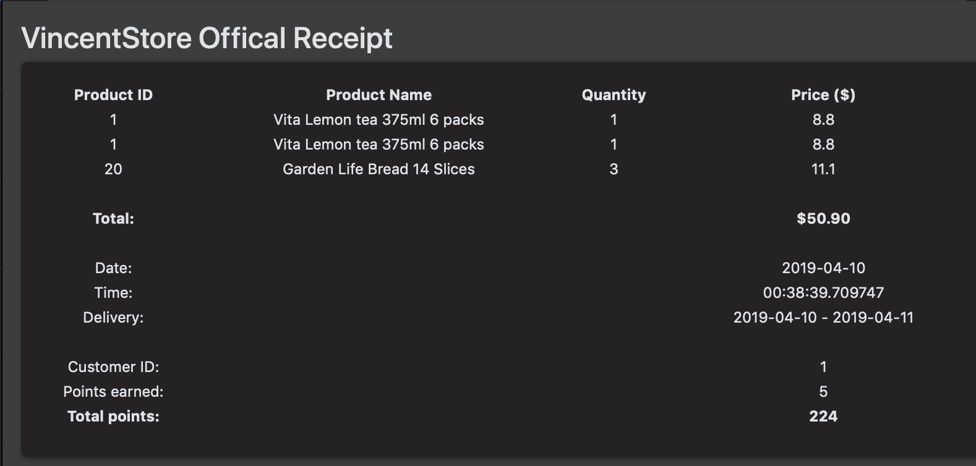
* Shopping record
  + List all the purchase record with its details (allow customer to check its record)
  + 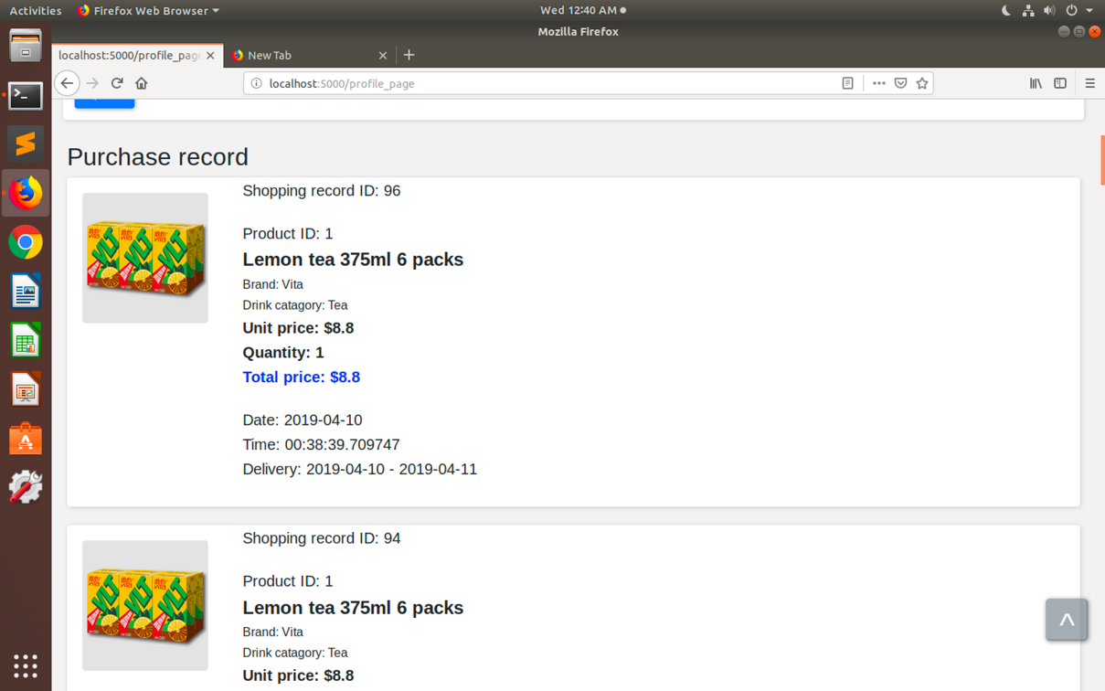
* Main page
  + Latest news of the store
  + Latest discount
  + 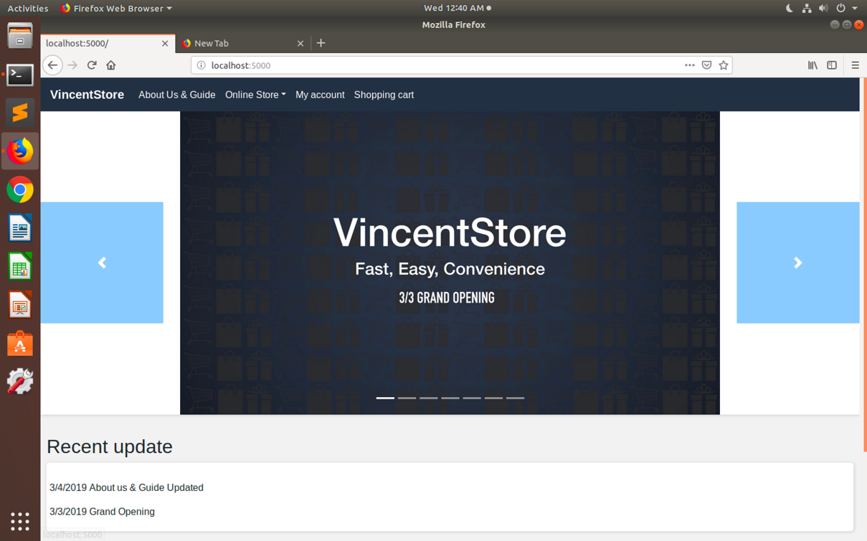
* About us page
  + A simple guide for our user to easily understand our store
  + 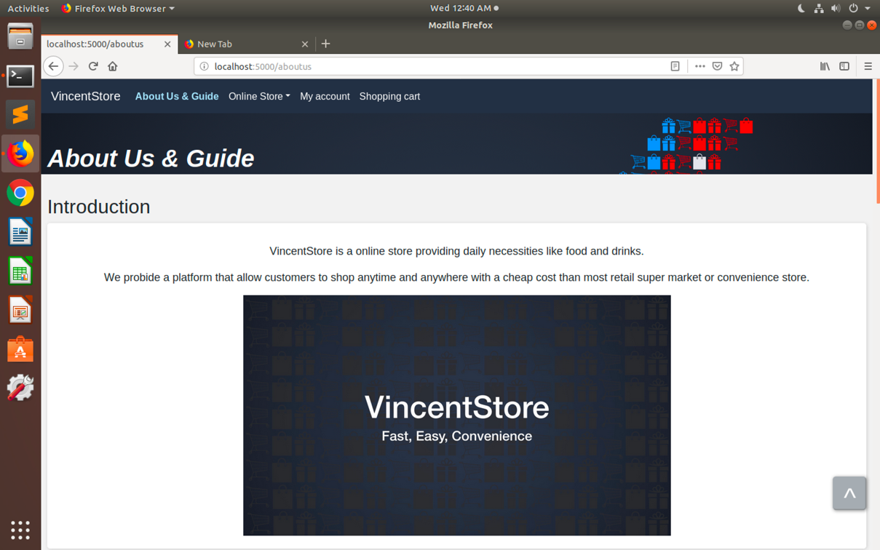

## Staff webpage

* Login/ logout
* View products
  + Update details of product
  + 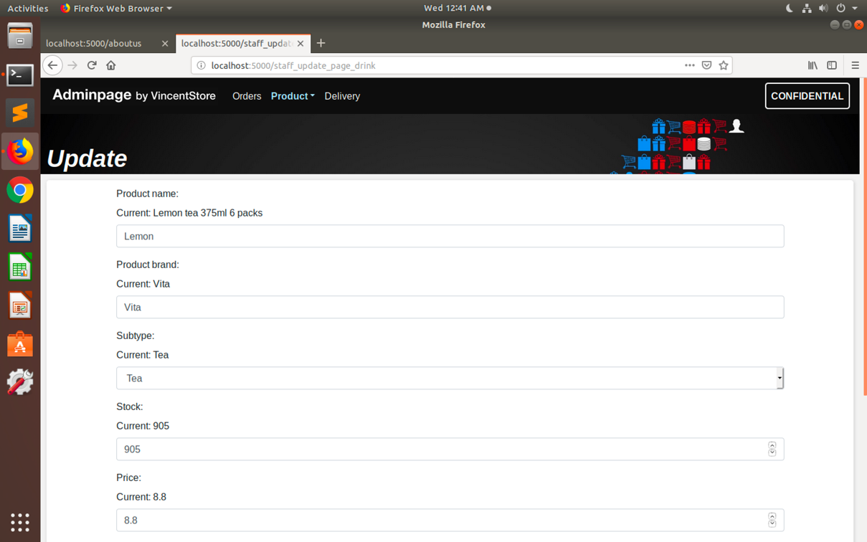
    - E.g. name, price, number in stock, category
  + Sort by product category
  + 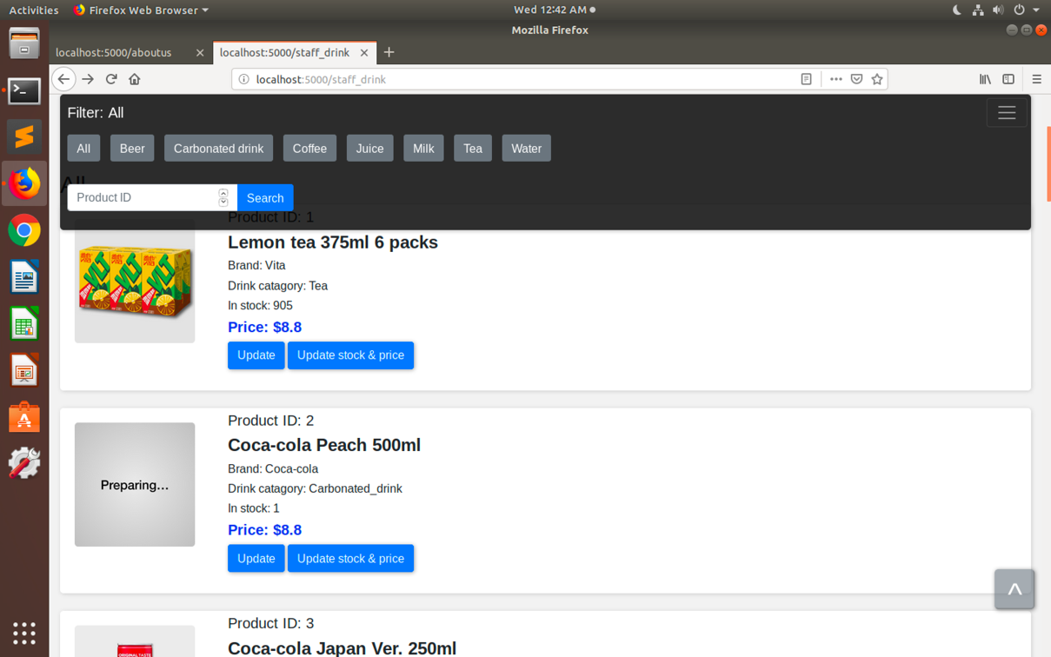
    - E.g. Cup noodles, ice cream, milk
  + Sort by product price
  + Search by product id
* Insert new product
  + 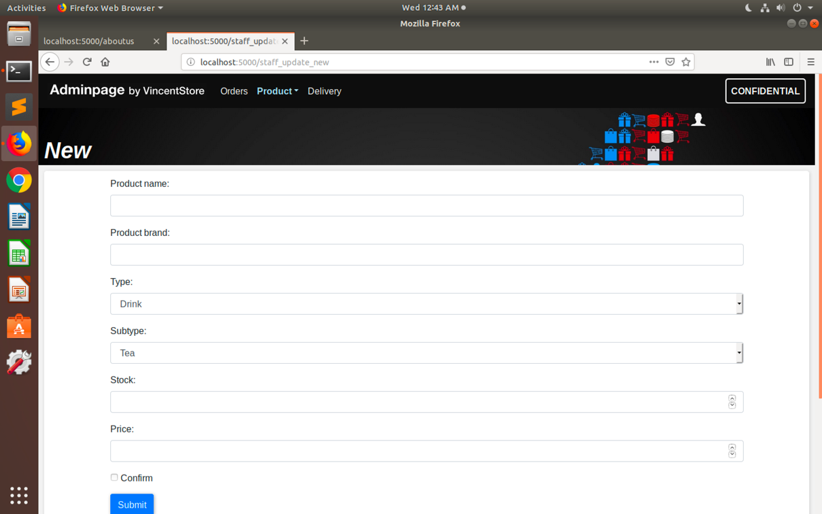
* Upload product photo (will be shown near details of product in various page like drink page)
  + 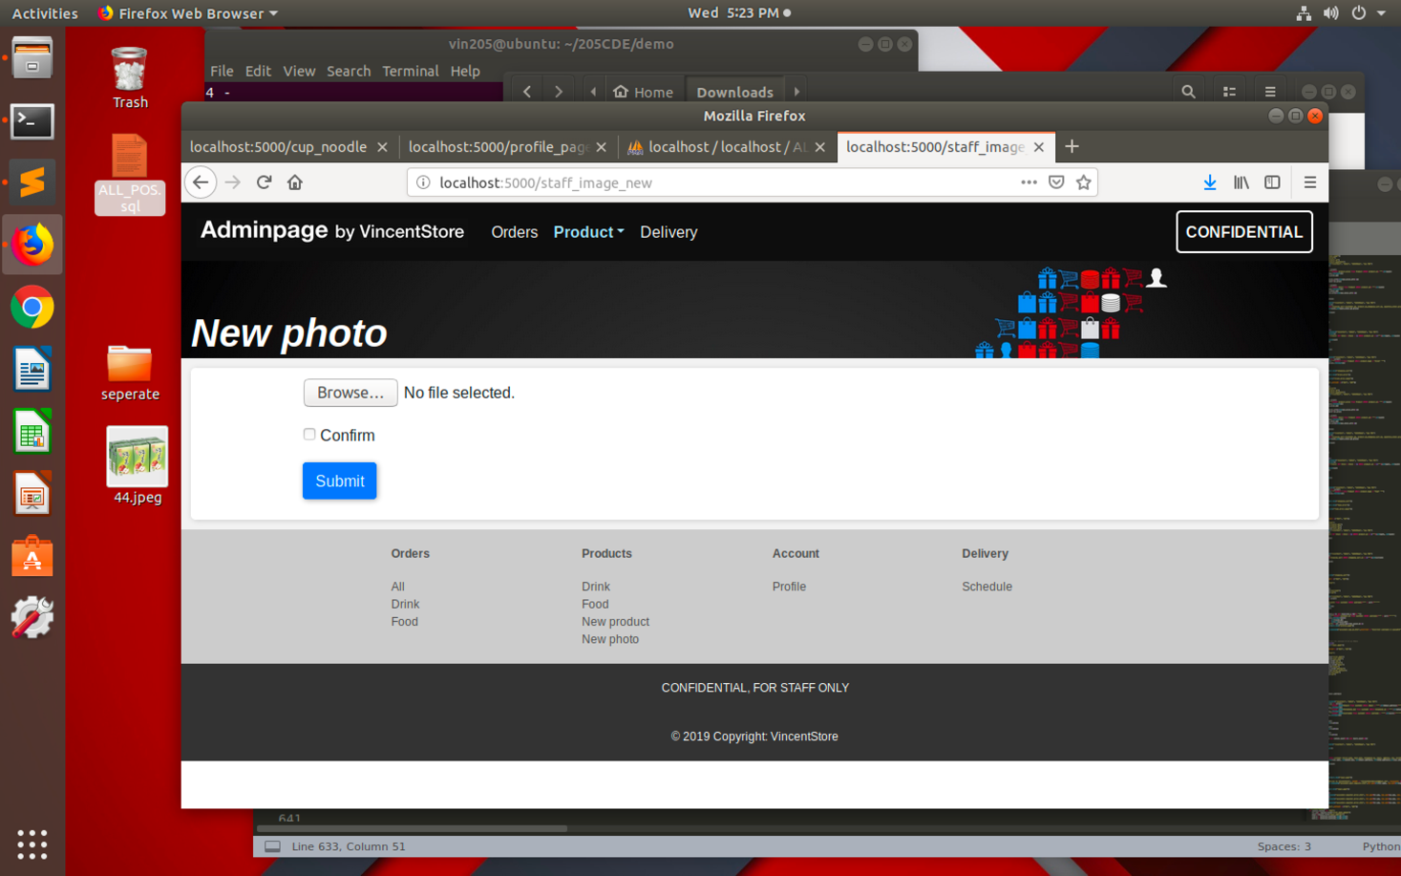
* View account details
  + 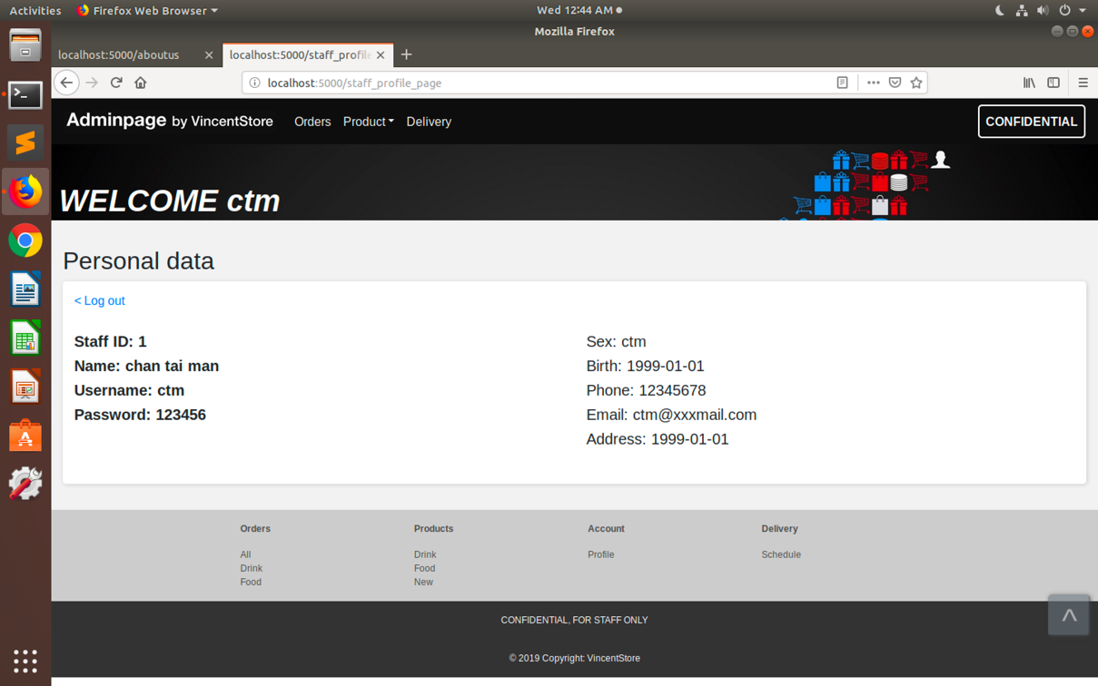
* View orders (allow staff to check recent order by customer and help them in need)
  + 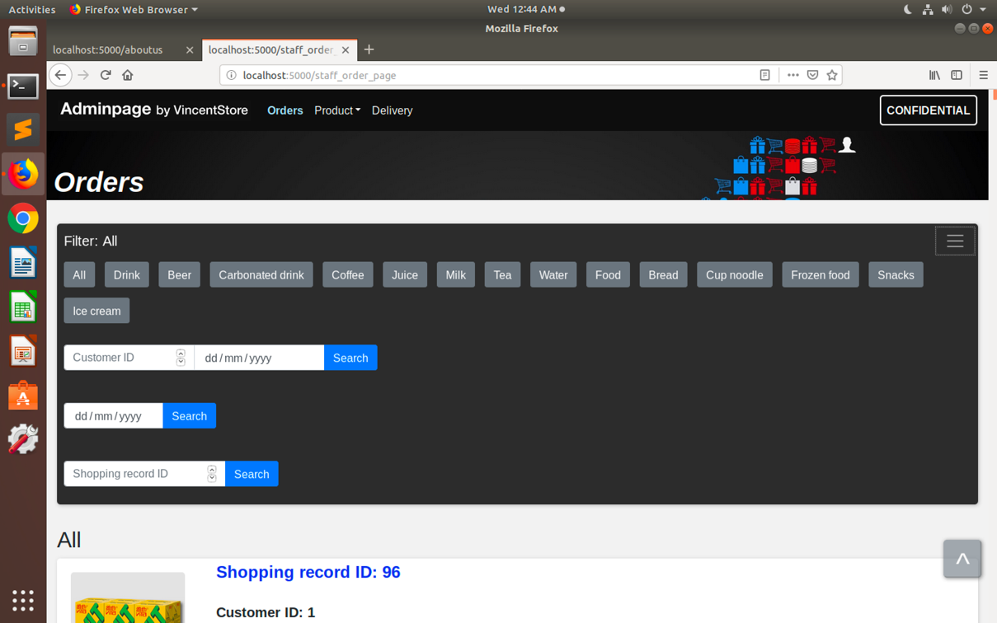
  + Sort by product category
    - E.g. Cup noodles, ice cream, milk
  + Sort by customer id and date
  + Search by shopping record id
  + Sort by date
* Update delivery date
  + 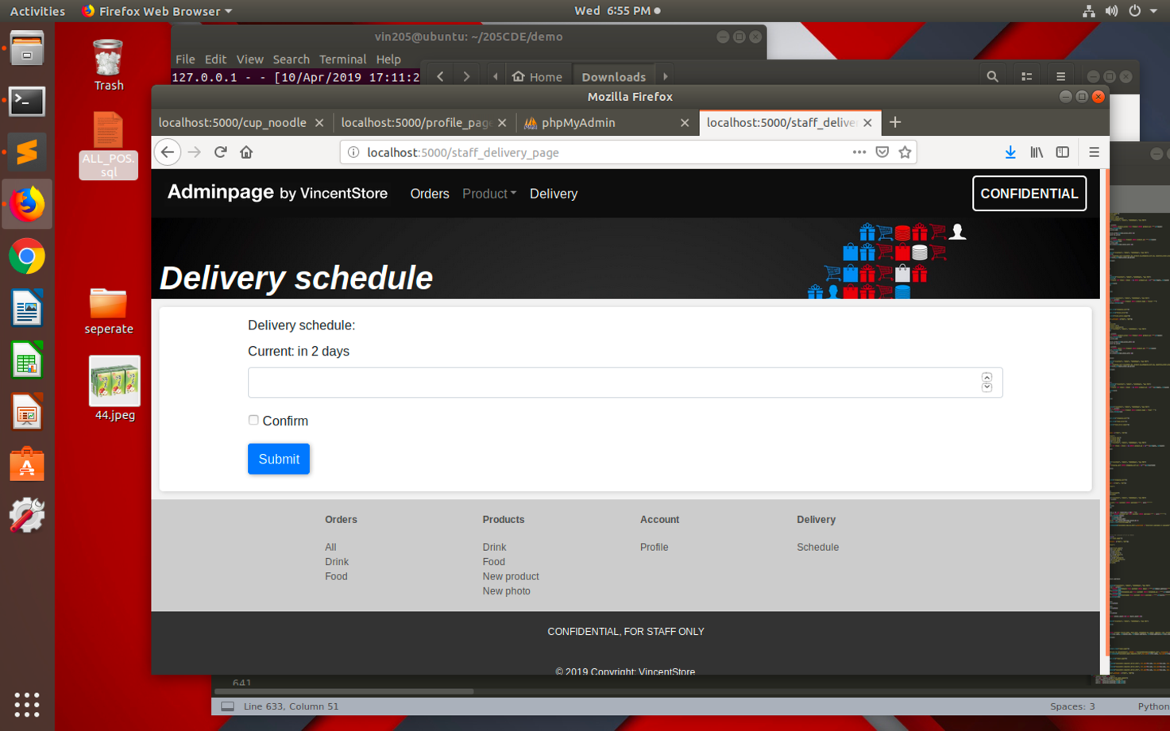
  + This allow staff to change delivery date easily if needed

# Design

The website makes use of html, CSS, JavaScript, jQuery, Bootstraps, flask, PyMySql and phpMyAdmin during development.

# Structure of web site

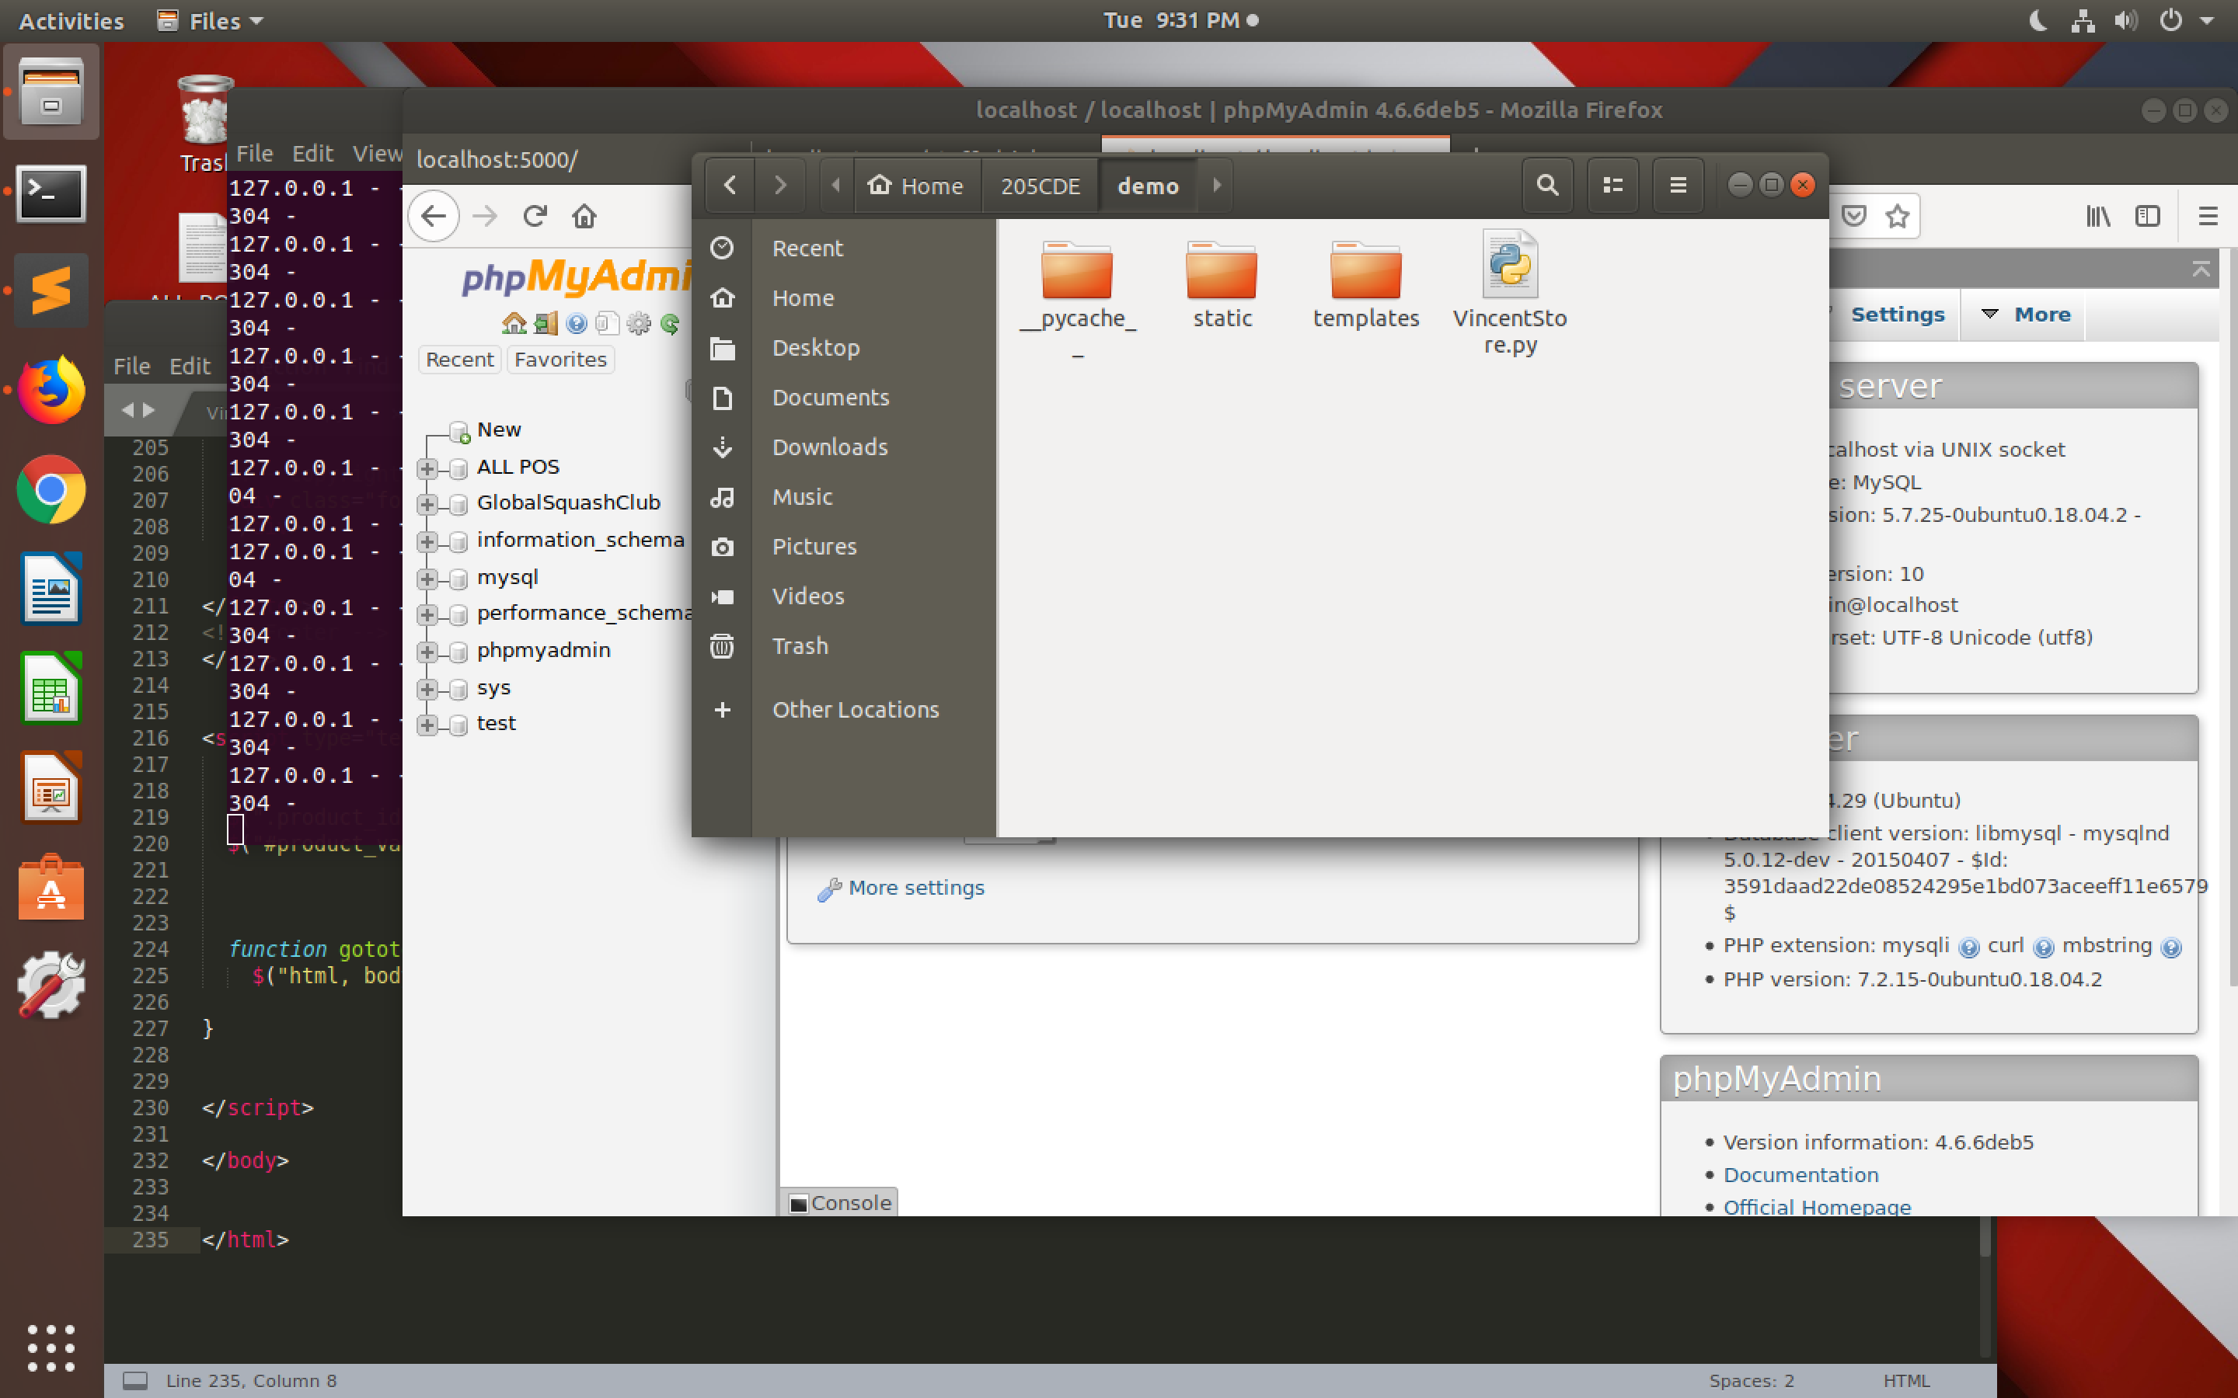

All files are stored under file “demo“.

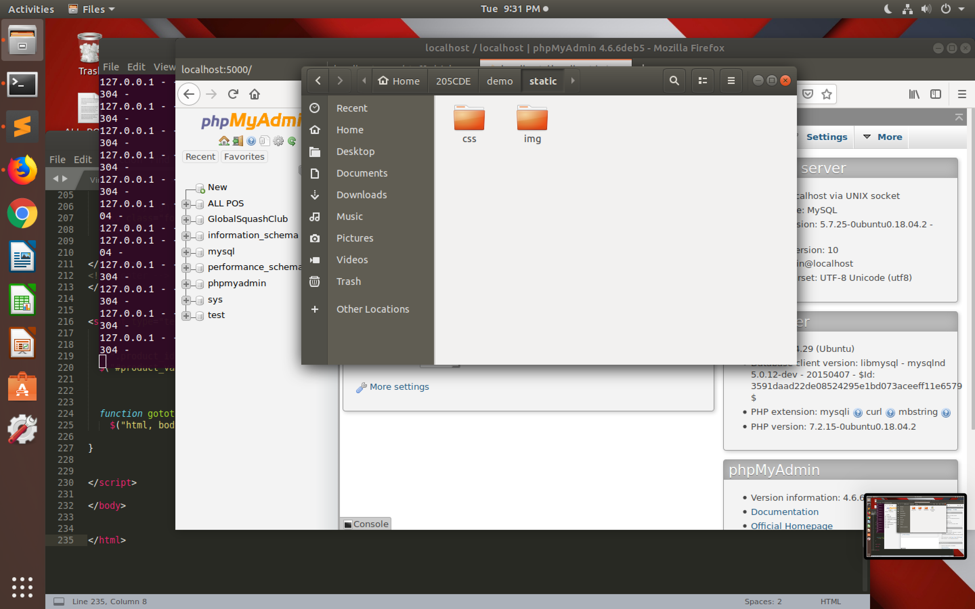

Under the “static” folder, there are two other folders: “css” and “img”.

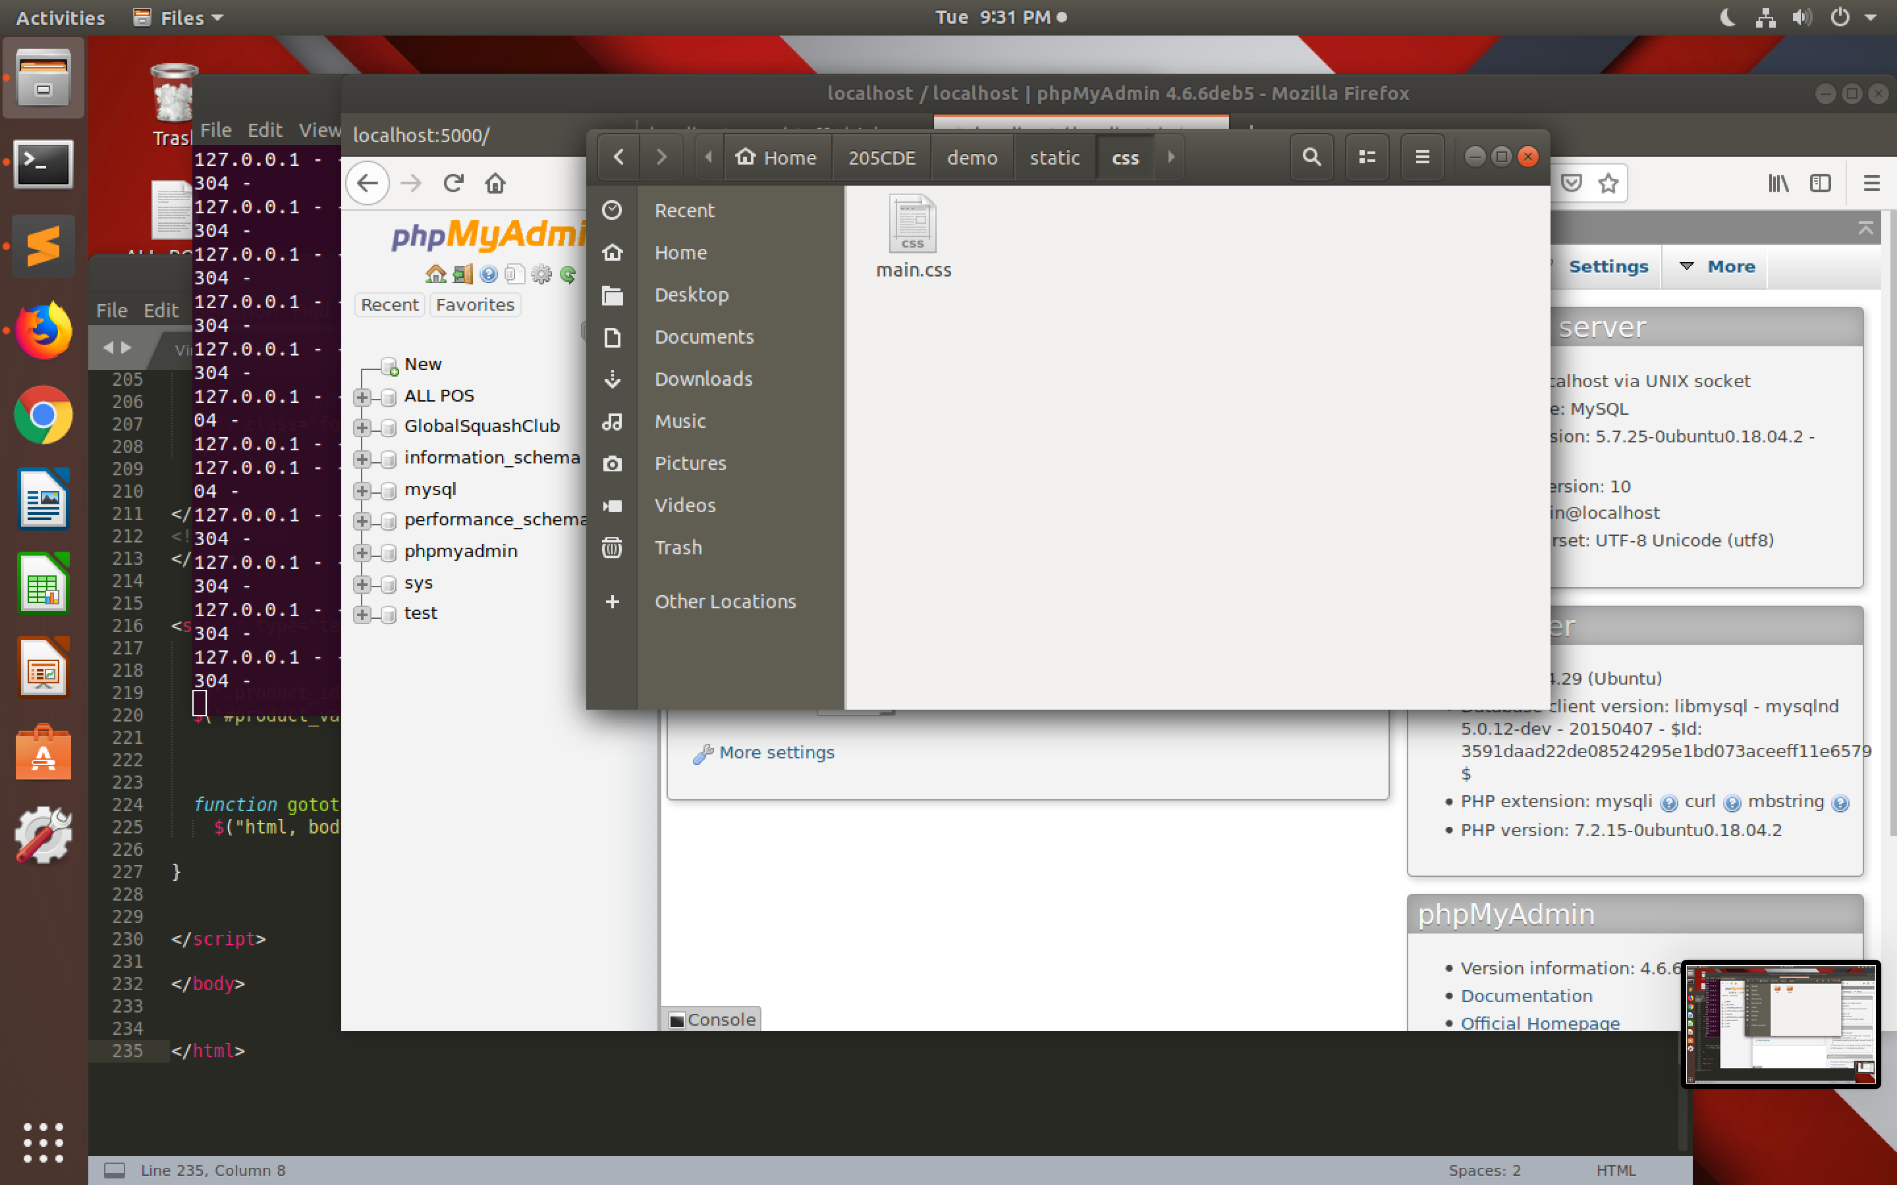

Under “css” folder, it stored the only CSS file: “main.css”.

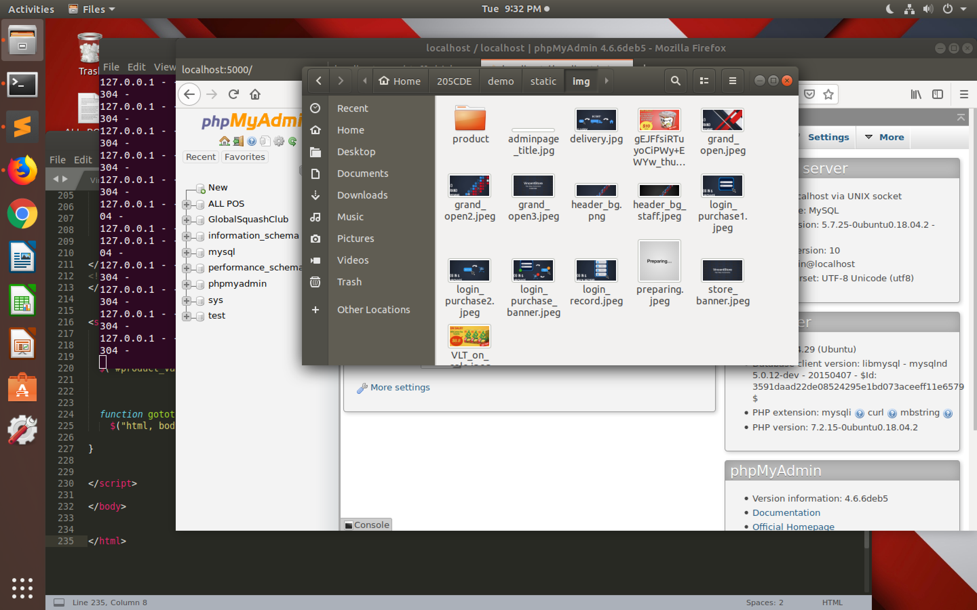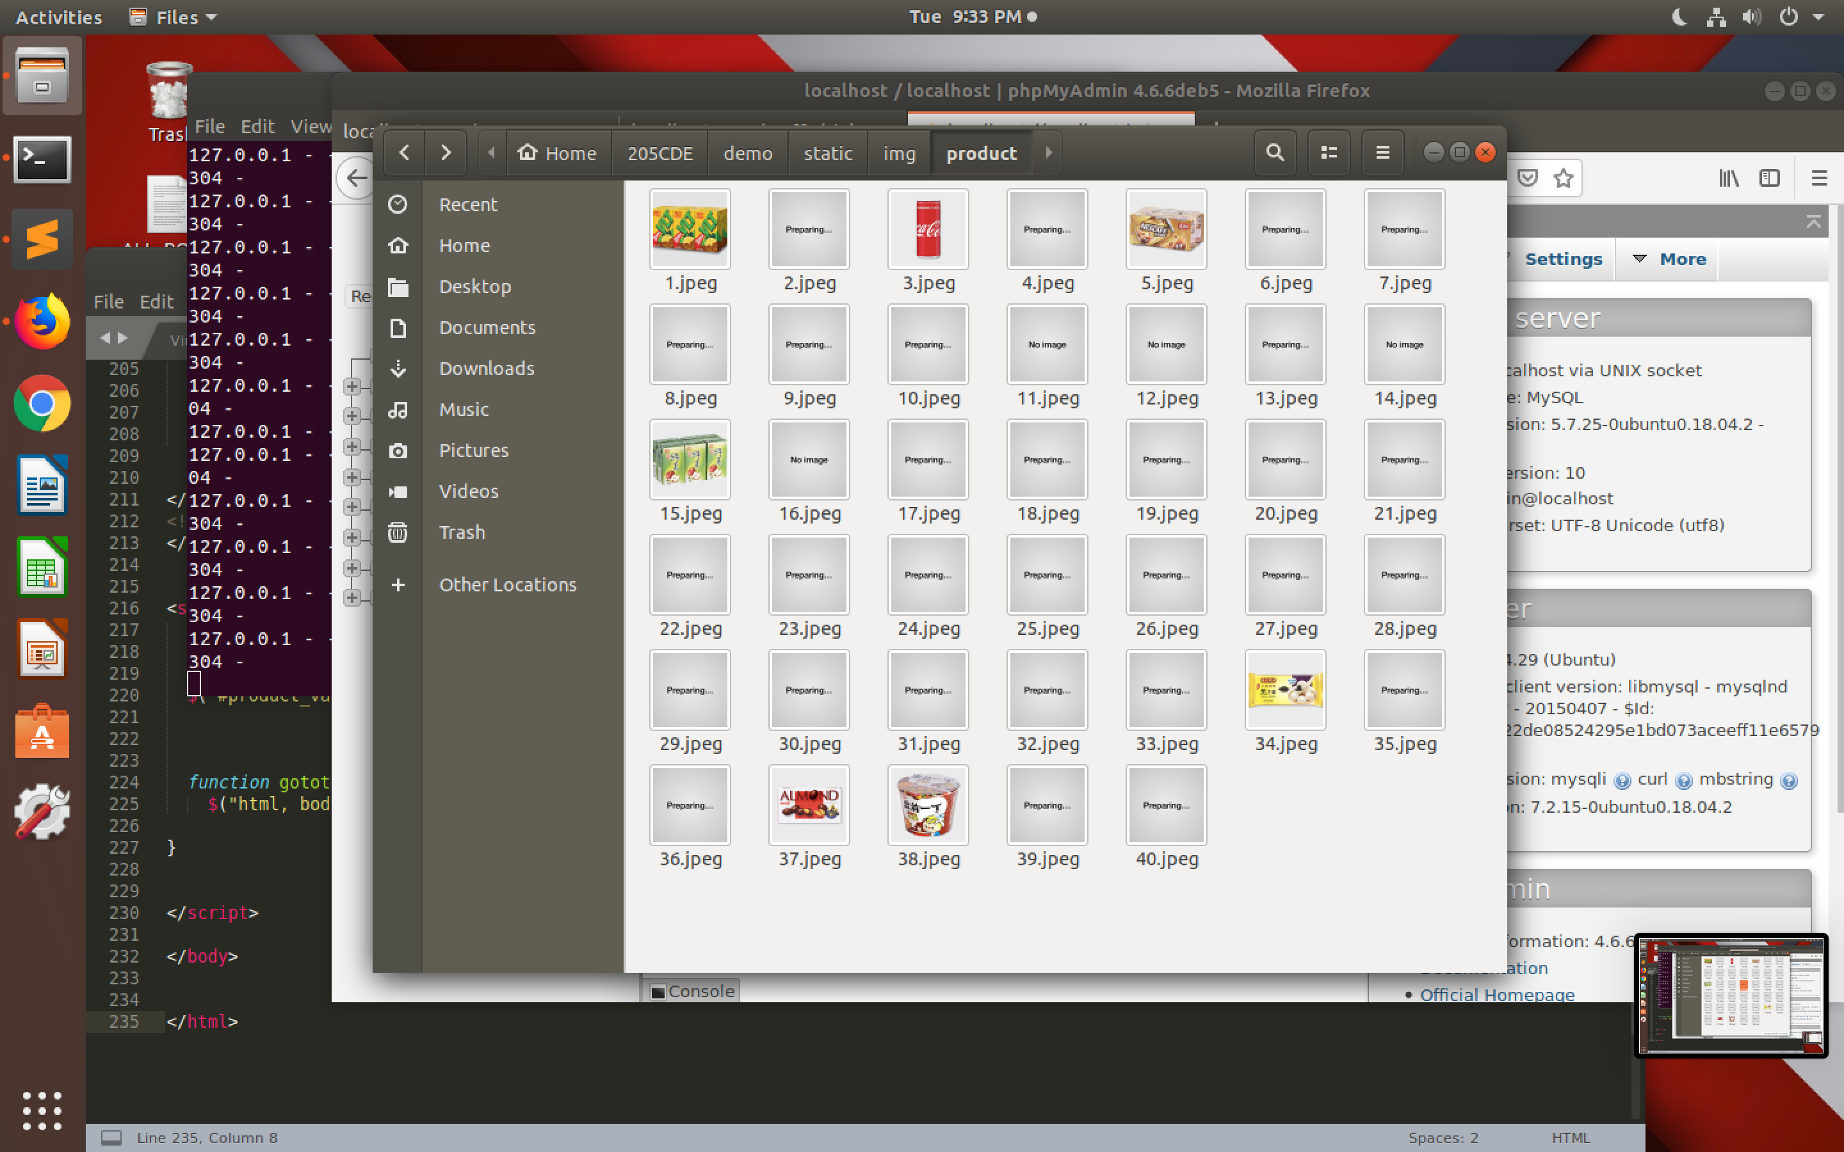

“img” folder stores all image needed for the website except products image which are stored under “product” file.

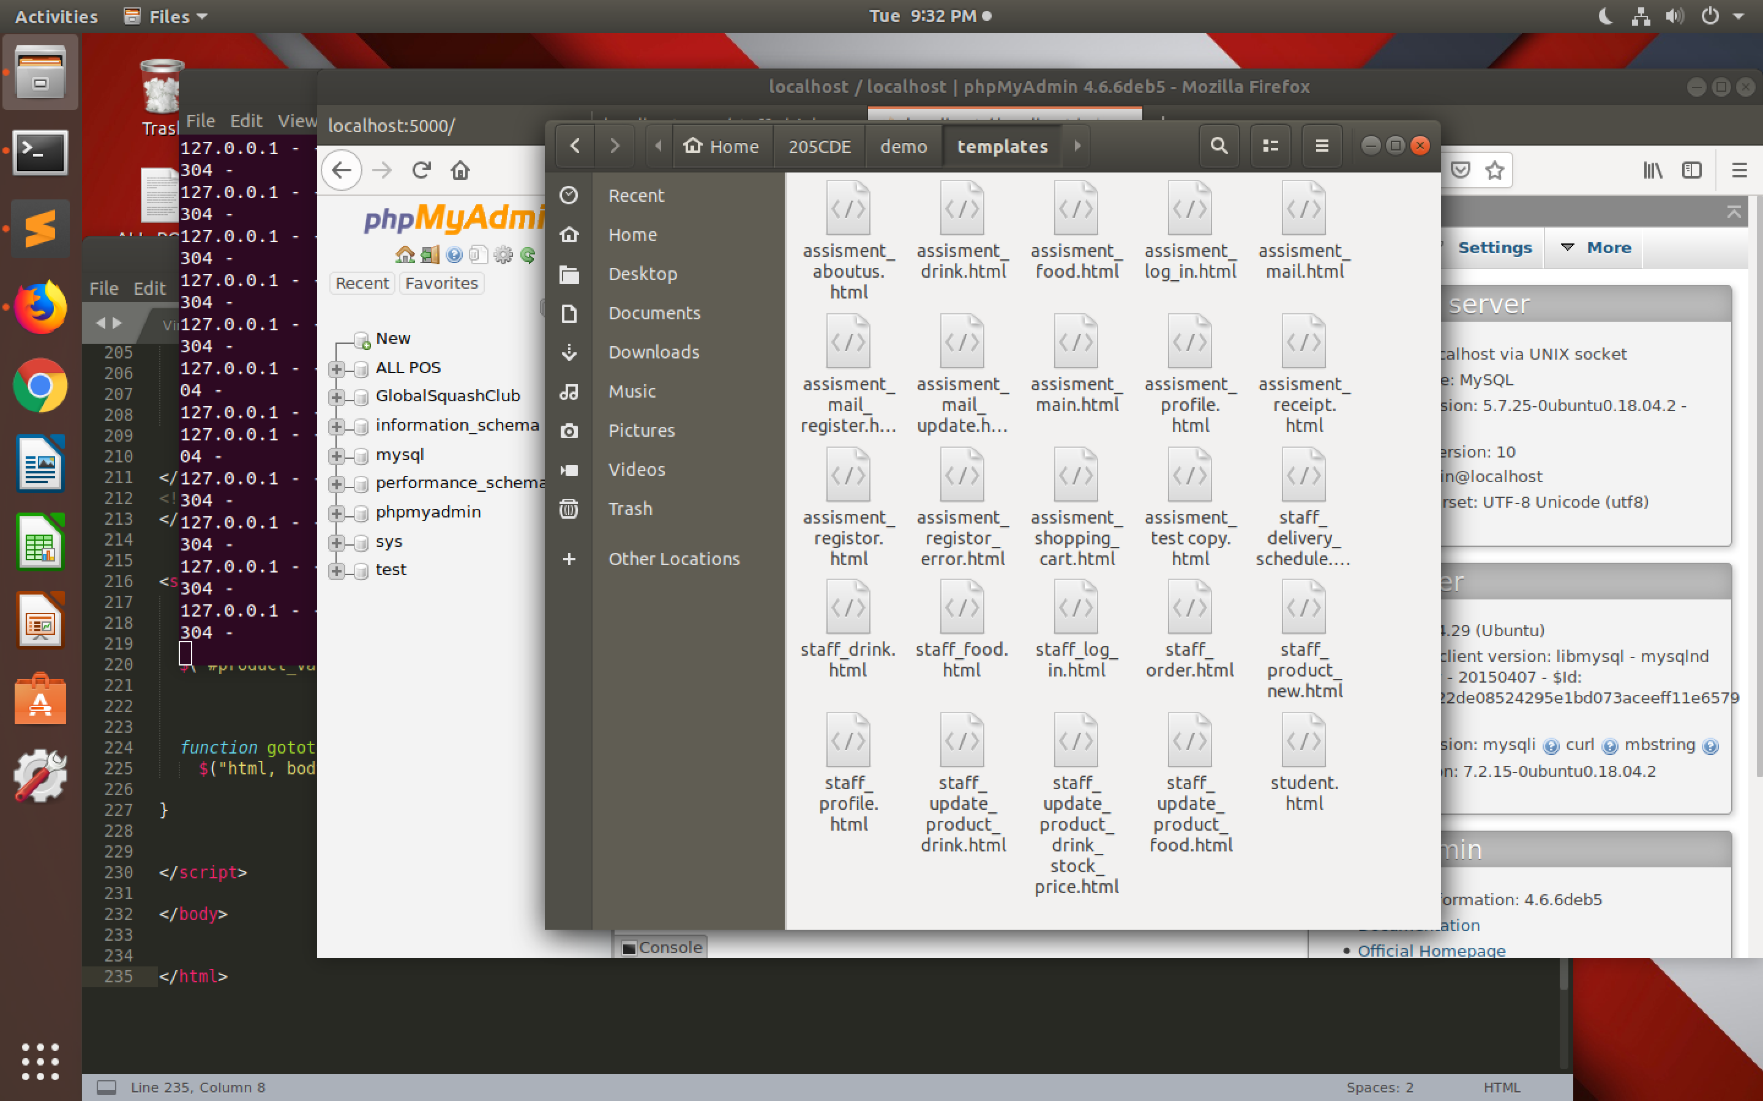

All the html files are store under “template” folder.

# Code

## Python

db = pymysql.connect("localhost", "admin", "123456aaa", "ALL POS")

with db.cursor() as cursor:

cursor.execute( """SELECT Product.*, Shopping_cart.quantity, Shopping_cart.total_price, Shopping_cart.shopping_cart_id from Product INNER JOIN Shopping_cart ON Product.product_id=Shopping_cart.product_id WHERE Shopping_cart.customer_id = """+str(session["Userid"])+""" ORDER BY product_id """)

pd_list=(cursor.fetchall())

cursor.execute( """SELECT total_price FROM Shopping_cart WHERE customer_id = """+str(session["Userid"]))

pd_list_price_qt=(cursor.fetchall())

db.close()

for row in pd_list_price_qt:

pd_price+=float(row[0])

This allow python connect to the database and extract the data need for the shopping cart page like shopping_cart_id, product_id and product price

db2 = pymysql.connect("localhost", "admin", "123456aaa", "ALL POS")

cursor = db2.cursor()

i=0

while i < len(pd_id_1):

sql2 = """INSERT INTO Shopping_record (customer_id, product_id, shopping_record_id, quantity, total_price, date_purchase, time_purchase, delivery_date) VALUES(%d,%d,NULL,%d,%f,'%s','%s','%s') """\

%(int(session["Userid"]),int(pd_id_1[i]),int(pd_qt_1[i]),float(pd_total_price_1[i]),date_p,time_p,date_delivery)

try:

cursor.execute(sql2)

db2.commit()

except:

db2.rollback()

i+=1

db2.close()

This allow python document to connect to database and insert the information to shopping_record table which will be done after customer pay.

db4 = pymysql.connect("localhost", "admin", "123456aaa", "ALL POS")

cursor = db4.cursor()

i=0

while i < len(pd_cart_id_1):

sql3="""DELETE FROM Shopping_cart WHERE shopping_cart_id = %d"""%(int(pd_cart_id_1[i]))

try:

cursor.execute(sql3)

db4.commit()

except:

db4.rollback()

i+=1

db4.close()

This part of program shows how to remove a record from database if the user would like to remove one item in shopping cart.

from flask_mail import Mail, Message

mail=Mail(app)

app.config['MAIL_SERVER']='smtp.gmail.com'

app.config['MAIL_PORT'] = 465

app.config['MAIL_USERNAME'] = 'VincentStoreOnline@gmail.com'

app.config['MAIL_PASSWORD'] = 'mumgor-kaxjah-xygZi9'

app.config['MAIL_USE_TLS'] = False

app.config['MAIL_USE_SSL'] = True

mail = Mail(app)

msg = Message('Receipt', sender = 'VincentStoreOnline@gmail.com', recipients = [cus_email[0]])

msg.html = render_template("assisment_mail.html",pd_list =pd_list,sum=("%.2f" %pd_price),date=date_p, time=time_p ,delivery2=date_delivery, cusid=session["Userid"], earn=cus_pt_earn,cuspt=cus_pt)

mail.send(msg)

This part of code allow our website to send email to our user like receipt

db = pymysql.connect("localhost", "admin", "123456aaa", "ALL POS")

cursor = db.cursor()

sql="""UPDATE Product SET Stock = Stock - %d WHERE product_id = %d"""%(int(pqt), int(pid))

try:

cursor.execute(sql)

db.commit()

except:

db.rollback()

db.close()

This part of code shows the update of stock of a product

from werkzeug.utils import secure_filename

UPLOAD_FOLDER = '/home/vin205/205CDE/demo/static/img/product'

ALLOWED_EXTENSIONS = set(['txt', 'pdf', 'png', 'jpg', 'jpeg', 'gif'])

def allowed_file(filename):

return '.' in filename and \

filename.rsplit('.', 1)[1].lower() in ALLOWED_EXTENSIONS

file = request.files['pic']

if file and allowed_file(file.filename):

filename = secure_filename(file.filename)

file.save(os.path.join(app.config['UPLOAD_FOLDER'], filename))

This part of code allow staff to upload a product image through our system to the specific path.

session["Staffid"] = str_cusid_db[1:len_cusid_db-2]

This allow the web page to remember if the user has logged in to the webpage.

session.pop('Staffid', None)

This allow the web page to logout the webpage.

return render_template("staff_log_in.html",incorrect = "Incorrect username or password")

This render_template allow the python document display the right website and content after processing.

## Html, Bootstrap, CSS

<nav class="navbar sticky-top navbar-expand-sm navbar-dark" style="background-color: rgba(33, 44, 63,0.98);">

<a class="navbar-brand" style="color:white ;font-weight:bold;" href="http://localhost:5000/" method = "POST">VincentStore</a>

<button class="navbar-toggler" type="button" data-toggle="collapse" data-target="#collapsibleNavbar">

<span class="navbar-toggler-icon"></span>

</button>

<div class="collapse navbar-collapse" id="collapsibleNavbar">

<ul class="navbar-nav">

<li class="nav-item">

<a class="nav-link" style="color:white" href="http://localhost:5000/aboutus" method = "POST">About Us & Guide</a>

</li>

<li class="nav-item dropdown">

<a class="nav-link dropdown-toggle" style="color:white" herf="#" id="navbardrop "data-toggle="dropdown">Online Store</a>

<div class="dropdown-menu">

<a class="dropdown-item" href="http://localhost:5000/drink" method = "POST">Drink</a>

</form>

<a class="dropdown-item" href="http://localhost:5000/food" method = "POST">Food</a>

</div>

</li>

<li class="nav-item">

<a class="nav-link" style="color:white" href="http://localhost:5000/login_page" method = "POST">My account</a>

</li>

<li class="nav-item">

<a class="nav-link" style="color:white" href="http://localhost:5000/shopping_cart" method = "POST">Shopping cart</a>

</li>

</UL>

</div>

</nav>

This part of code display and generate the navigator bar on top of website

<div id="demo" class="carousel slide" data-ride="carousel">

<!-- Indicators -->

<ul class="carousel-indicators">

<li data-target="#demo" data-slide-to="0" class="active"></li>

<li data-target="#demo" data-slide-to="1"></li>

<li data-target="#demo" data-slide-to="2"></li>

<li data-target="#demo" data-slide-to="3"></li>

<li data-target="#demo" data-slide-to="4"></li>

<li data-target="#demo" data-slide-to="5"></li>

<li data-target="#demo" data-slide-to="6"></li>

</ul>

<!-- The slideshow -->

<div class="carousel-inner" style="background-color: white; box-shadow: 1px 1px 5px #cccccc;">

<div class="row">

<div class="col-lg-2 col-md-1"></div>

<div class="col-lg-8 col-md-10">

<div class="carousel-item active ">

<a href="http://localhost:5000/aboutus" method = "POST"><img src="/static/img/grand_open3.jpeg" class="main_carousel" alt="grand open 1" ></a>

</div>

<div class="carousel-item ">

<a href="http://localhost:5000/food" method = "POST"><img src="/static/img/gEJFfsiRTuyoCiPWy+EWYw_thumb_97d.jpg" class="main_carousel" alt="cup noodle on sale" ></a>

</div>

<div class="carousel-item">

<a href="http://localhost:5000/aboutus" method = "POST"><img src="/static/img/grand_open2.jpeg" class="main_carousel" alt="grand open 2" ></a>

</div>

<div class="carousel-item">

<a href="http://localhost:5000/tea" method = "POST"><img src="/static/img/VLT_on_sale.jpeg" class="main_carousel" alt="VLT on sale" ></a>

</div>

<div class="carousel-item">

<a href="http://localhost:5000/aboutus" method = "POST"><img src="/static/img/login_purchase1.jpeg" class="main_carousel" alt="login purchase 1" ></a>

</div>

<div class="carousel-item">

<a href="http://localhost:5000/aboutus" method = "POST"><img src="/static/img/login_purchase2.jpeg" class="main_carousel" alt="login purchase 2" ></a>

</div>

<div class="carousel-item">

<a href="http://localhost:5000/aboutus" method = "POST"><img src="/static/img/delivery.jpg" class="main_carousel" alt="Delivery" ></a>

</div>

</div>

</div>

</div>

<!-- Left and right controls -->

<a class="carousel-control-prev main_button" style=" top:30% ; " href="#demo" data-slide="prev">

<span class="carousel-control-prev-icon"></span>

</a>

<a class="carousel-control-next main_button" style=" top:30%;" href="#demo" data-slide="next">

<span class="carousel-control-next-icon"></span>

</a>

</div>

This part of code generates the carousel part of the main page, which display some banners on screen and change to another banner when times change.

<div id="list_of_product">

{% for item in drink_list %}

<div class="product" style="padding: 5px;">

<div class="row">

<div class="col-sm-4 col-xl-2 ">

<img src="/static/img/product/{{item[0]}}.jpeg" class="product_photo" style=" height: 100% ;width:100%; max-width: 200px; max-height: 200px">

</div>

<div class="col-sm-8 col-xl-10 " id= {{item[0]}}>

<tr>

<td><h5>Product ID: {{item[0]}}</h5></td>

<td><h4 style="font-weight: bold">{{item[1]}}</h4></td>

<td><h6>Brand: {{item[2]}}</h6></td>

<td><h6>Drink catagory: {{item[6]}}</h6></td>

<td><h6>In stock: {{item[4]}}</h6></td>

<td><h5 style="font-weight: bold;color:#0039e6">Price: ${{item[3]}}</h5></td>

<form action = "http://localhost:5000/purchase_drink" target="_blank" method = "POST">

<button class="btn btn-primary">Add to cart</button>&nbsp;

<input type="number" name="product_quantity" class="Quantity_box" value="1" min="1" max="10" placeholder="&nbsp;Quantity" style="padding-bottom : 5px">

<input type="text" value="{{item[0]}}" name="product_id" class="product_id_text">

</form>

</tr>

<br>

</div>

</div>

</div>

<br>

{% endfor %}

This part of code allow products from database could be shown on screen with specific format. The dedicated button for each product will also be generated in order to add to cart. The data use jinja 2 to import from python and database.

<form action = "http://localhost:5000/purchase_drink" target="_blank" method = "POST">

This part of code allows the html files to post data to python files

## JavaScript, jQuery

$(".product_id_text").hide();

This code allow the website to hide the elements in class “product_id_text”.

function gototop() {

$("html, body").animate({ scrollTop: 0 }, 300);

}

This part of code allow screens move to the top automatically if user press the buttons.

function phone_check() {

var phone=document.getElementById("phone").value;

if (phone.length!== 8){

document.getElementById("invalid_phone").innerHTML = "Should be 8 digit";

$("#register_submit").hide()

}else{

document.getElementById("invalid_phone").innerHTML = "";

$("#register_submit").show()

}

}

This part of code is introduced in order to check is the inputted phone number is in correct format.

function pw_check(){

var usr_pw = document.getElementById("pwd").value;

var pw_check_identify=false;

var pw_check_identify2=false;

var check_include_num=/\d/;

var check_include_char=/[A-Z]/i;

$("#register_submit").hide()

if(pw_check_identify==false){

document.getElementById("invalid_password").innerHTML = "Must contain letters (A-Z/a-z) and numbers (0-9)";

}

if (usr_pw.match("^[a-zA-Z0-9]+$")){

if(usr_pw.match(check_include_num)){

if(usr_pw.match(check_include_char)){

pw_check_identify=true;

}

}

}

if(usr_pw.length<8){

document.getElementById("invalid_password_len").innerHTML = "Must at least 8 characters in length";

} else{document.getElementById("invalid_password_len").innerHTML = "";

pw_check_identify2=true}

if((pw_check_identify2==true)&&(pw_check_identify==true)){

$("#register_submit").show()

document.getElementById("invalid_password").innerHTML = "";

document.getElementById("invalid_password_len").innerHTML = "";

}

}

function pw_confirm_check(){

var usr_pw = document.getElementById("pwd").value;

var usr_pw_confirm = document.getElementById("pwd_confirm").value;

if (usr_pw !== usr_pw_confirm){

document.getElementById("invalid_password_cf").innerHTML = "Passwords are not same";

$("#register_submit").hide()

}else{

$("#register_submit").show()

document.getElementById("invalid_password_cf").innerHTML = "";

}

}

This part of code allows the system to check if the password is valid.

# Database design

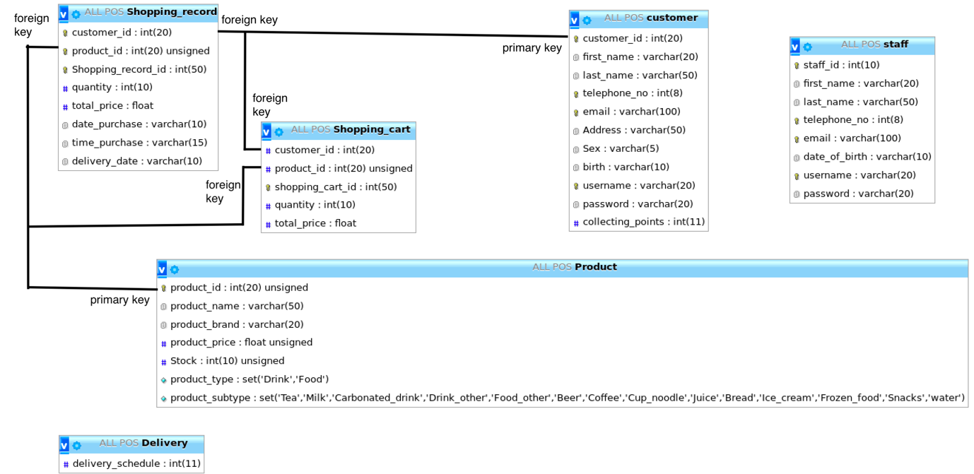

There are six database table in our system.

The product table stores the product information which is necessary for the program and the website to perform the daily tasks.

* primary key: product_id, it should be unique in the table to identify the product.
* Product_name and product_brand are variable character
* Product_price and quantity are integer
* Stock is an interger which stores the quantity of that product haven’t sold yet
* Product_type is a set to select ‘Drink’ or ‘Food’
* Product_subtype is a set to select the sub_category of the product e.g. (‘milk’, ’ice_cream’)

The staff table stores the staff personal information such as their name and the user name and password for login the staff website.

* The staff_id is a primary key to identify the staff
* The first_name and last_name are variable character
* Telephone_no is an integer and should be unique to identify the staff
* Email is a variable character and should be unique to identify the staff
* Date_of_birth is in date type
* Username is a unique variable character which is used for staff to login the POS system
* Password is a variable character which staff need to input when login

The customer table stores the customer information.

* The customer_id is a primary key to identify the customer
* The first_name, last_name, Sex, birth and Address are variable character
* Telephone_no is an integer and should be unique to identify the customer
* Email is a variable character and should be unique to identify the customer
* Username is a unique variable character which is used for customer to login the website
* Password is a variable character which customer need to input when login
* Collecting_points is an integer that stores the points collected of each customer after purchase in our shop

The Shopping_cart table stores the data in shopping cart.

* The customer_id is a foreign key to identify the customer
* The product_id is a foreign key to identify the product
* The shopping_cart_id is a primary key to identify the item in shopping cart
* Quantity is an integer stores the quantity of each shopping cart item
* total_price is a float which store the total price of each shopping cart item

The Shopping_record table stores the data in shopping cart.

* The customer_id is a foreign key to identify the customer
* The product_id is a foreign key to identify the product
* The shopping_record_id is a primary key to identify the item in shopping record
* Quantity is an integer stores the quantity of each shopping record item
* total_price is a float which store the total price of each shopping record item
* date_purchase and time_purchase are variable character that stores data and time of purchase

The Delivery table stores the delivery date

* delivery_schedule is a integer which stores the delivery date

# Recommendation for browsers

## Browser version

|  |  |  |  |
| --- | --- | --- | --- |
| Safari | Chrome | Firefox | Edge |
| 5.0 | 5.0 | 4.0 | 10.0 |

## OS version

|  |
| --- |
| Windows 7 or later |
| OS X (macOS) 10.8 or later |
| iOS 9 or later |
| Android 5 or later |

# Evaluation

The design of the web site meets the basic needs of our store. However, some aspects of the website could be improved to even convince the customer and staff and prepared for the future development of our store.

# Future development

Refund

* In the current state of website, staff need to manually remove the record in database with no record of what is being refunded. A refund table and a website refund function could be introduced which allow for easier processing and generate a record of record for viewing in the future.

Popular product session/ Staff selected product session/ New product session

* This session may increase the sales of the products as customer could easily to know what product is trending or new arrival.

Provide discount to customer

* Currently, discount could only be provided by changing the price in database. However other discount like “buy one get one free” or membership discount could not be provided now. By implementing this feature, the sales of the store could be boosted.

# List of References

Hktv mall (2019a) *Coca-Cola - Japan Coca-Cola 250ml* [online] available from

< <https://www.hktvmall.com/hktv/en/main/95-Darb8-Limited/s/S6010001/Supermarket/Supermarket/Beverages/Soft-Drinks/Japan-CocaCola-250ml/p/S6010001_S_F1555>> [10 April 2019]

Hktv mall (2019b) *Demae Iccho - Spicy Beef Flavour Instant Noodle (Bowl Noodle)* [online]

available from < https://www.hktvmall.com/hktv/en/main/NISSIN-Foods-%28H-K-%29-Co-%2C-Ltd/s/H1061001/Supermarket/Supermarket/Noodles-%26-Pasta/Cup-Noodles/Cup-Noodles/Spicy-Beef-Flavour-Instant-Noodle-Bowl-Noodle/p/H0888001_S_10020619B> [10 April 2019]

Hktv mall (2019c) *MEIJI - Almond Chocolate* [online] available from

< https://www.hktvmall.com/hktv/en/main/大街市/s/H0888001/Supermarket/Supermarket/Snacks-%26-Desserts/Chocolate/Nutty-Chocolate/Almond-Chocolate/p/H0888001_S_10017398> [10 April 2019]

Hktv mall (2019d) *Nescafé - Coffee Beverage - Regular (Can)* [online] available from

< https://www.hktvmall.com/hktv/en/main/大街市/s/H0888001/Supermarket/Supermarket/Beverages/Instant-Coffee-Milk-Tea/Instant-Coffee/Coffee-Beverage-Regular-Can/p/H0888001_S_10021220> [10 April 2019]

Hktv mall (2019e) *Vita - Apple Green Tea* [online] available from

<https://www.hktvmall.com/hktv/en/main/VITASOY/s/H1077001/Supermarket/Supermarket/Beverages/Tea-Drinks/Paper-packed-Tea/Apple-Green-Tea/p/H0888001_S_10000034> [10 April 2019]

Hktv mall (2019f) *Vita - Lemon Tea* [online] available from

<https://www.hktvmall.com/hktv/en/main/VITASOY/s/H1077001/Supermarket/Supermarket/Beverages/Tea-Drinks/Paper-packed-Tea/Lemon-Tea/p/H0888001_S_10003330> [10 April 2019]

Hktv mall (2019g) *Wan Chai Ferry - Sesame Tongyuen (Frozen)* [online] available from

< <https://www.hktvmall.com/hktv/en/main/Wan-Chai-Ferry/s/H1110001/Supermarket/Supermarket/Chilled-Frozen-Food/Dessert%26Cakes/Sesame-Tongyuen-Frozen/p/H0888001_S_10130125>> [10 April 2019]

Tutorialspoint (2019) *Flask Tutorial* [online] available from

<https://www.tutorialspoint.com/flask> [25 March 2019]

W3schools.com (2019a) *CSS Tutorial* [online] available from

<<https://www.w3schools.com/css/default.asp>> [7 March 2019]

W3schools.com (2019b) *HTML5 Tutorial* [online] available from

<https://www.w3schools.com/html/default.asp> [7 March 2019]

W3schools.com (2019c) *JavaScript Tutorial* [online] available from

<https://www.w3schools.com/js/default.asp> [19 March 2019]

W3schools.com (2019d) *jQuery Tutorial* [online] available from

<https://www.w3schools.com/jquery/default.asp> [22 March 2019]